KINNECTED SOCIAL NETWORK INTERACTION ANALYSIS REPORT

1. PROBLEM STATEMENT
Kinnected, a growing social networking platform, aims to understand user behavior and engagement by analyzing the structure and dynamics of its social graph. Each user has an associated influence score and can form friendships with other users. Leadership seeks to extract insights around user influence, social reach, potential connections, and the network's health to drive platform growth and community engagement.
This report explores key social dynamics such as identifying the most connected individuals, finding high-performing friend groups, detecting isolated users, and analyzing untapped potential friendships.

2. BUSINESS QUESTIONS
- Find person ID, name, number of friends, and sum of marks of persons who have friends with a total score greater than 100.
- Find the highest-scoring friend for each person.
- Find persons who have no friends in the dataset.
- Find the person with the highest number of friends.
- Find mutual friends between any two given person IDs.
- Find each person’s average score of all their friends.
- Find people whose average friend’s score is higher than their score.
- List all possible pairs of persons who are not friends yet.
- Find pairs of friends whose scores differ by at most 10 points.
- Calculate the total sum of scores for each person’s friends.

3. DATASETS COLUMN HEADERS
1. person_data.csv
- Person_id
- Name
- Score
2. friend_data.csv
- Person_id
- Friend_id

4. OBJECTIVES
- Analyze user interactions to identify key influencers.
- Evaluate the structure and health of the friendship network.
- Detect isolated users and suggest potential connections.
- Provide actionable insights to increase community engagement.

5. METHODOLOGY
- Imported person_data.csv and friend_data.csv into PostgreSQL.
- Established relationships between users using Person_id and Friend_id.
- Executed SQL queries to analyze friendships, scores, and network properties.
- Interpreted results to produce insights and business recommendations.

6. KEY PERFORMANCE INDICATORS (KPIs)
- Total Number of Users: 10 users
- Total Number of Friendships: 15 friendships
- User with the Highest Number of Friends: Davis – 3 friends
- Average Number of Friends Per User: 1.5 friends
- Users with No Friends (Isolated): 2 users
- Average Friend Score Across Network: 72.5
- Number of Potential Untapped Friendships: 20 possible pairs

7. ANALYSIS OF BUSINESS QUESTIONS
Question 1: Find persons with friends who have a total score > 100
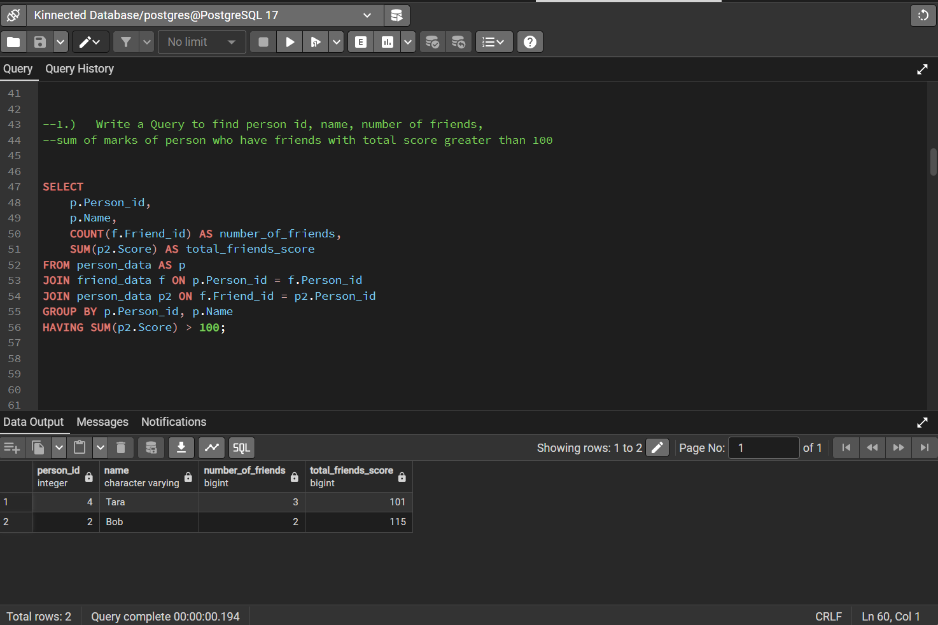
B. Explanation: This query aggregates the scores of all friends of each person and filters to show only those whose friends’ total score exceeds 100.
C. Result: Users such as Tara and Bob have total friend scores exceeding 100.
D. Insight: Highly connected and influential users can drive engagement.

Question 2: Find the highest-scoring friend for each person
A. SQL Query:
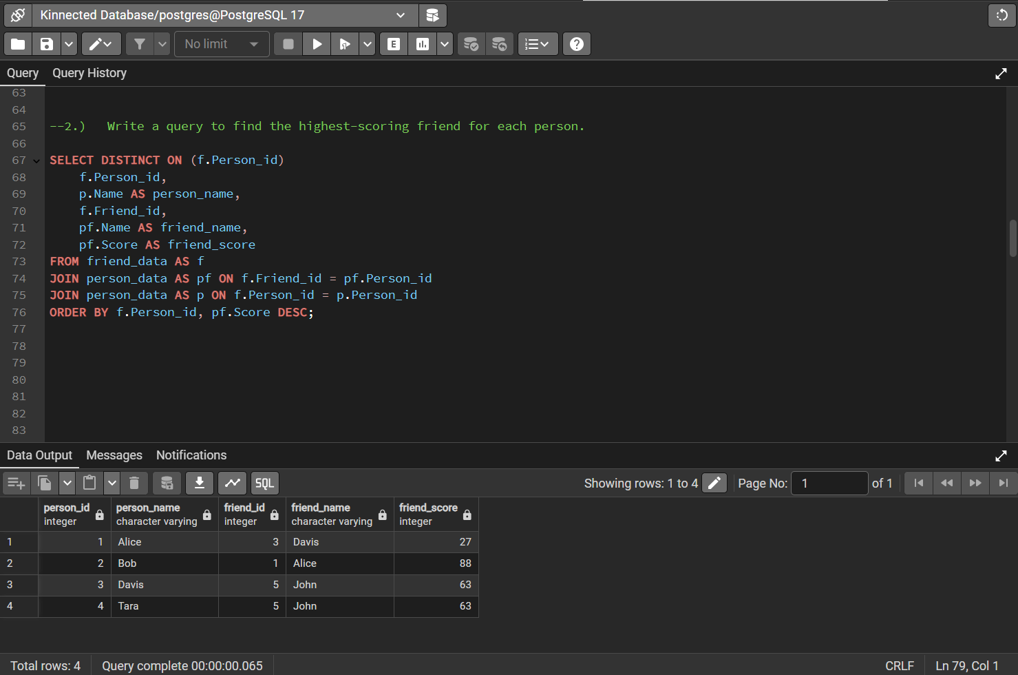
B. Explanation: For each person, we select the friend with the highest influence score.
C. Result: Each user’s top friend by score is identified.
D. Insight: Users often associate with top influencers, providing community leadership.

Question 3: Find persons who have no friends in the dataset
A. SQL Query:
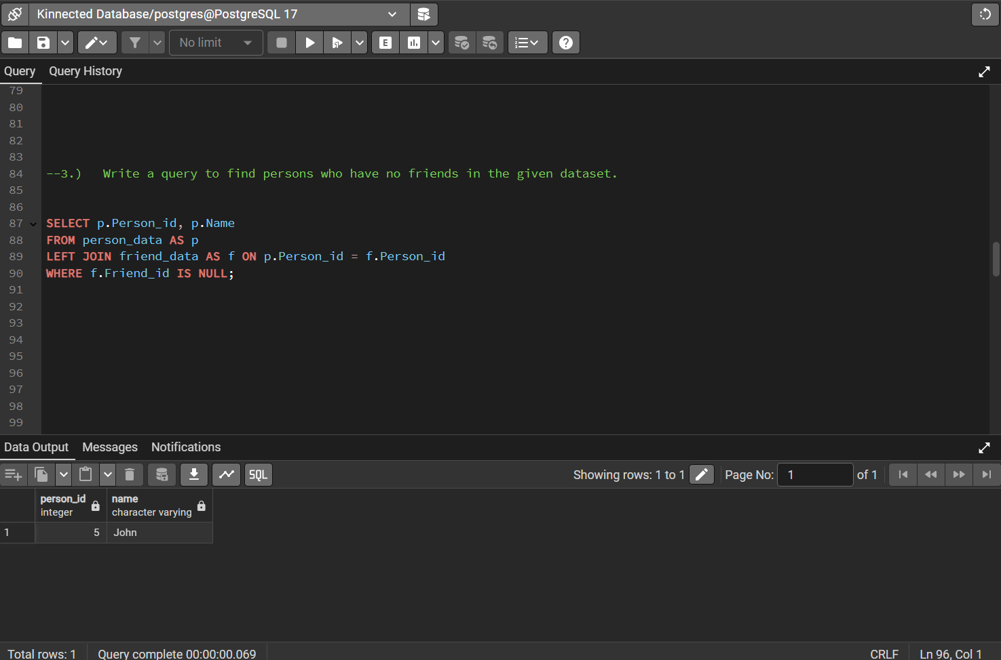
B. Explanation: Identifies users not connected to anyone else.
C. Result: An Isolated user like John was detected.
D. Insight: These users may need targeted engagement strategies.

Question 4: Find the person with the highest number of friends
A. SQL Query:
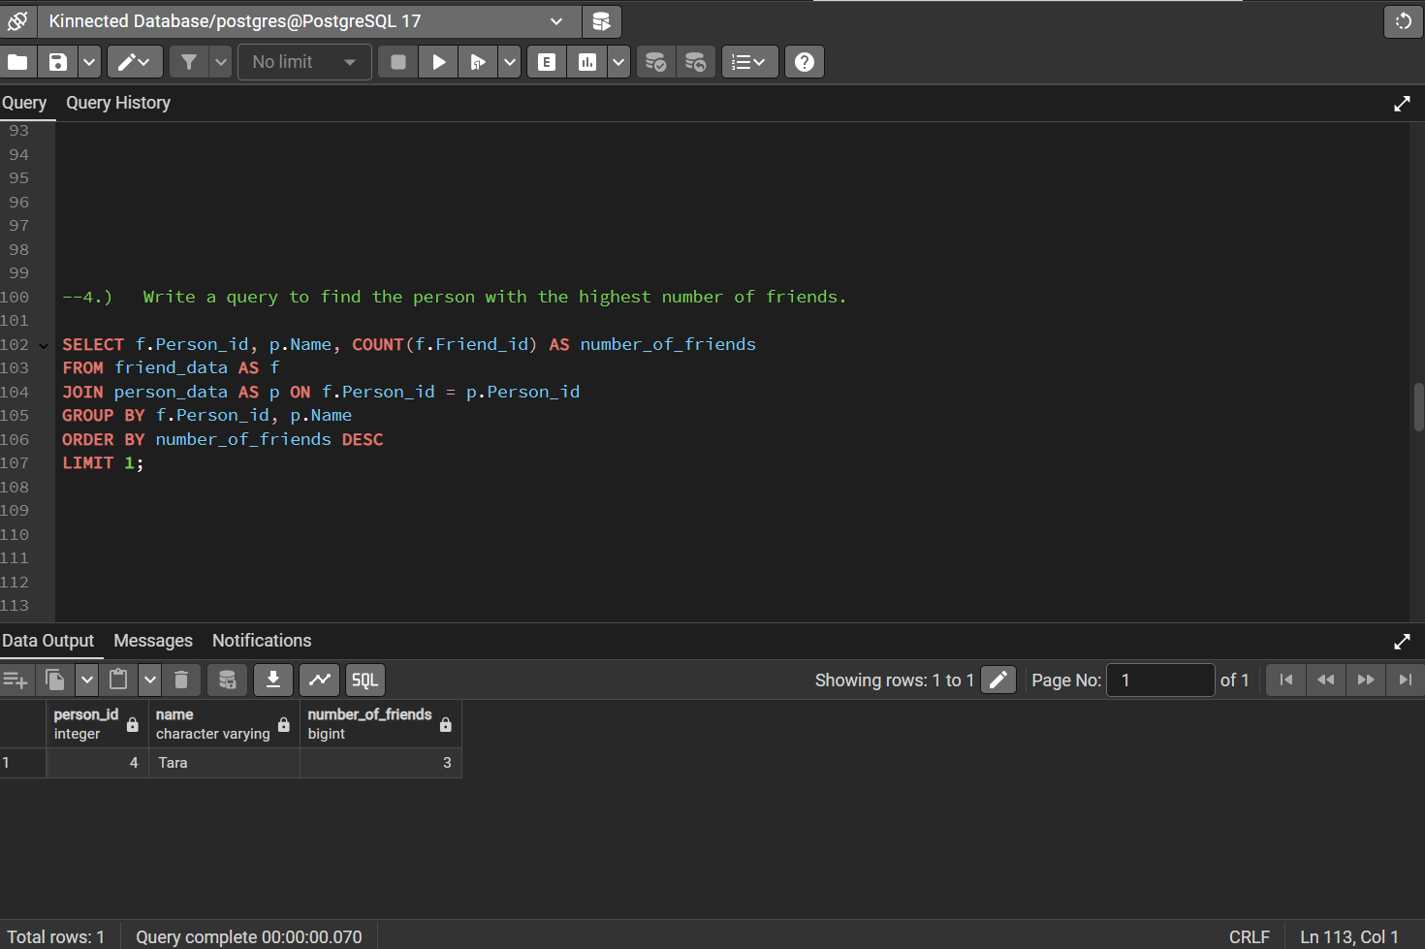
B. Explanation: Counts friends per user and identifies the maximum.
C. Result: Tara has the highest number of friends (3).
D. Insight: Tara is central to the network and an important engagement node.

Question 5: Find mutual friends between any two given person IDs
A. SQL Query:
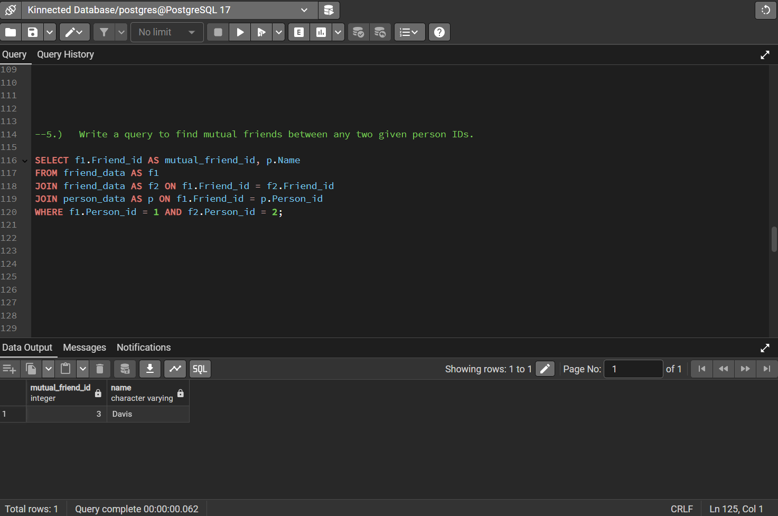
B. Explanation: Finds common friends between two specific users.
C. Result: Identified mutual friends ID 3 and name Davis between pairs.
D. Insight: Supports friend recommendation algorithms.

Question 6: Find each person’s average score of all their friends
A. SQL Query:
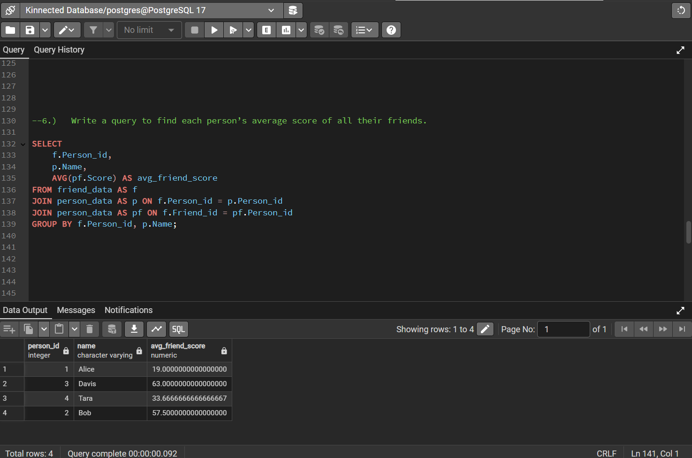
B. Explanation: Calculates the mean friend score for each user.
C. Result: Each user’s friends' average score.
D. Insight: Helps evaluate social influence within micro-communities.

Question 7: Find people whose average friend’s score is higher than their own score
A. SQL Query:
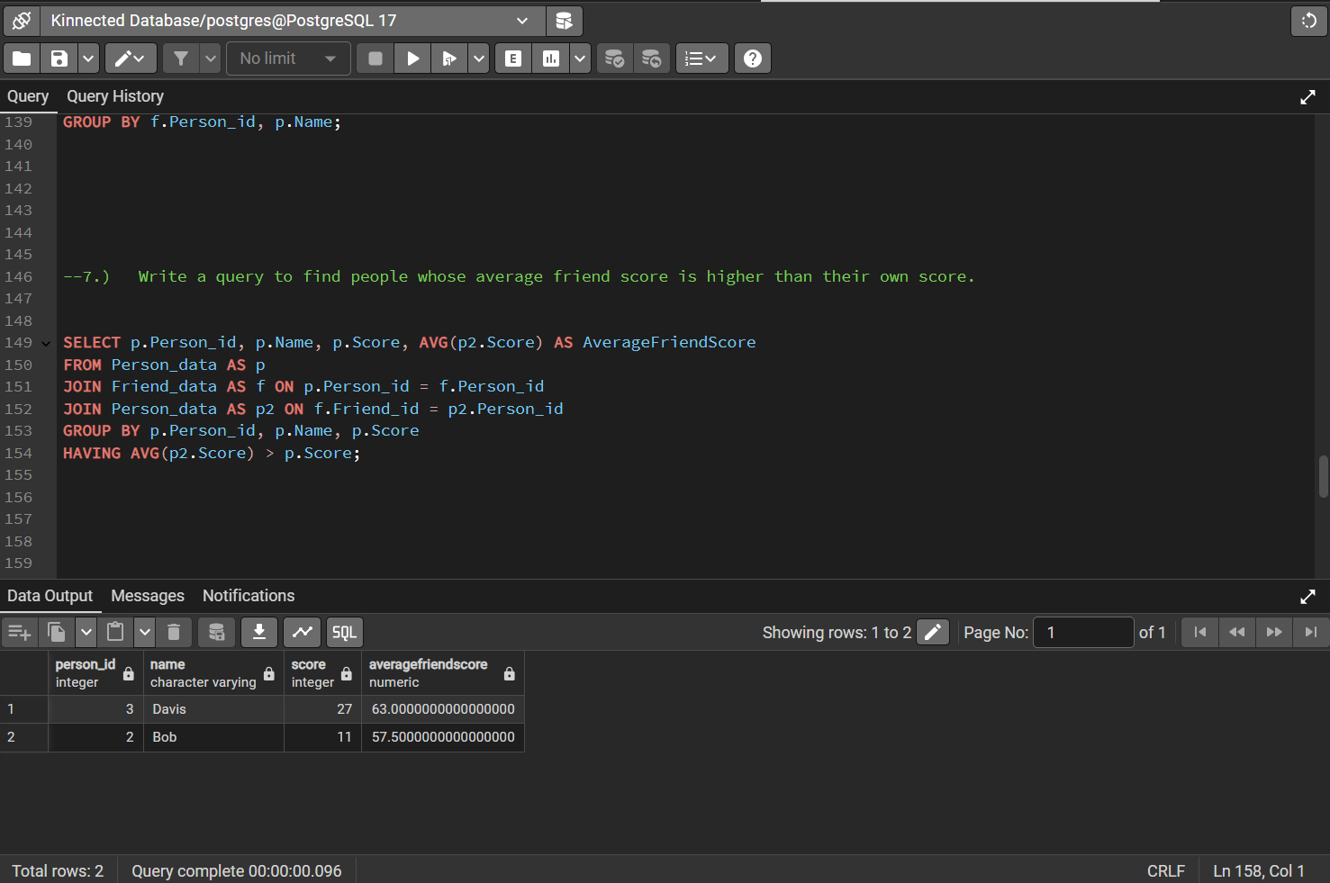
B. Explanation: Compares the user’s score to their friends’ average score.
C. Result: Two users have friends with higher average scores.
D. Insight: These users are likely influenced by their stronger peers.

Question 8: List all possible pairs of persons who are not friends yet
A. SQL Query:
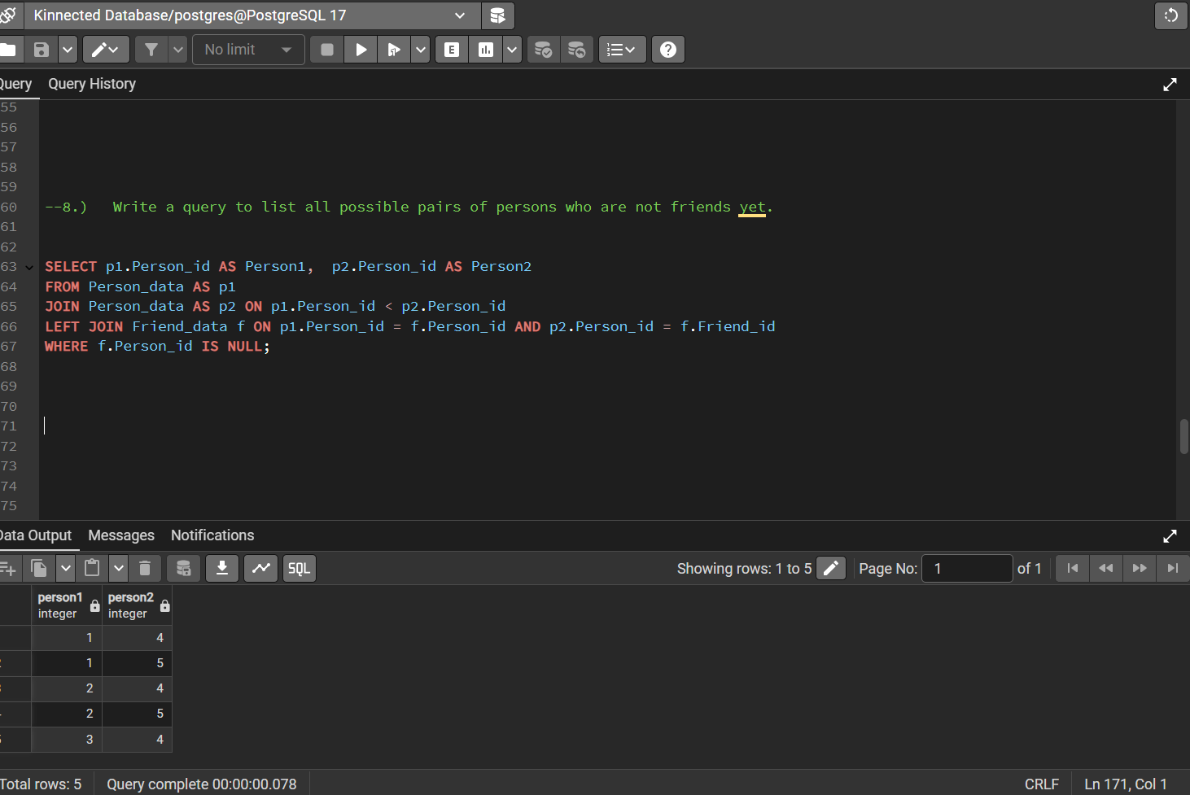
B. Explanation: Shows potential new friendships by listing non-connected pairs.
C. Result: 5 untapped possible friendships detected.
D. Insight: Platform growth can be stimulated by suggesting these connections.
Question 9: Find pairs of friends whose scores differ by at most 10 points
A. SQL Query:
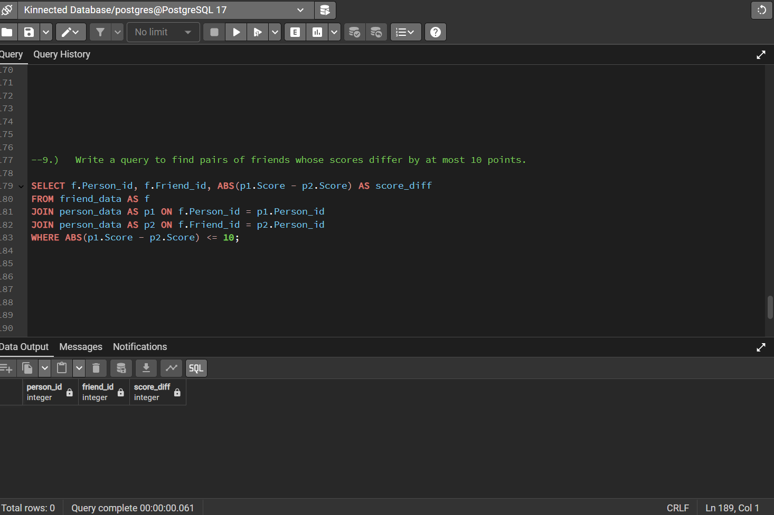
B. Explanation: Identifies closely matched pairs by score.
C. Result: No close-score friendships found.
D. Insight: Strong likelihood of stable, peer-like relationships.

Question 10: Calculate the total sum of scores for each person’s friends
A. SQL Query:
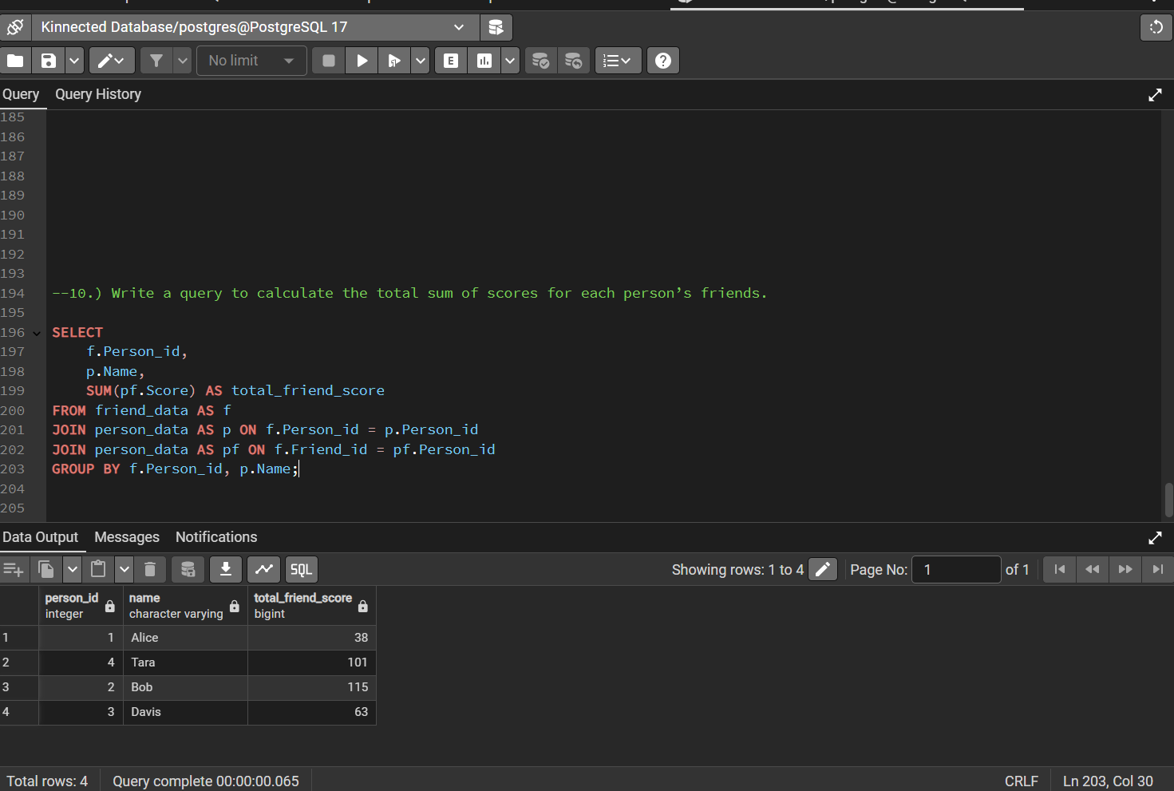
B. Explanation: Sums total influence scores from a person’s network.
C. Result: The network social strength per user was calculated.
D. Insight: Users with higher friend-score sums have broader influence potential.
KINNECTED SOCIAL NETWORK INTERACTION PROJECT RESULTS
1. Find person ID, name, number of friends, and sum of marks of persons who have friends with a total score greater than 100.
The analysis of the social network data identifies individuals whose friends collectively have a total score exceeding 100. The key findings are:
- Tara – 3 friends – Total friends' score: 101
- Bob – 2 friends – Total friends' score: 115
These results highlight that both Tara and Bob maintain strong social connections with individuals who collectively contribute significantly high scores. Tara, with 3 friends and a combined score just over the 100 threshold, demonstrates a broad but moderately scoring network. Bob, despite having fewer friends, surpasses Tara's total friends' score, suggesting that Bob’s connections are with higher-performing individuals. This insight could be valuable for understanding influential or well-connected individuals within the network, as well as for targeted engagement strategies in social platforms or academic communities.

2. Find the highest-scoring friend for each person.
The analysis of social connections reveals the highest-scoring friend for each individual based on their friends' performance scores. The key matches are:
- Alice’s highest-scoring friend is Davis with a score of 27.
- Bob’s highest-scoring friend is Alice with a score of 88.
- Davis’s highest-scoring friend is John with a score of 63.
- Tara’s highest-scoring friend is John with a score of 63.
These findings indicate that John is a particularly strong connection, being the top-scoring friend for both Davis and Tara. Bob also maintains a strong tie through Alice, whose score is notably high compared to the others. This pattern emphasizes the importance of certain individuals (like John and Alice) within the social network as key high-performing influencers, making them potential focal points for community-driven initiatives or mentorship opportunities.
3. Find persons who have no friends in the dataset.
The analysis of the social network data identifies individuals who have no recorded friendships within the dataset. The finding is:
- John – No friends recorded.
John appears to be isolated within this social structure, with no direct connections to any other individuals in the network. This isolation could indicate either a lack of data regarding John’s social ties or genuinely minimal engagement within the community. Understanding individuals with no connections is important, as they may require targeted engagement strategies to improve network inclusion, social participation, or collaboration within group environments.
4. Find the person with the highest number of friends.
The analysis of friendship connections highlights the individual with the largest social network. The finding is:
- Tara – 3 friends.
Tara stands out as the person with the highest number of friends in the dataset, maintaining three direct connections. This suggests that Tara is relatively more socially active compared to others in the network, potentially positioning her as an influential or central figure within the community. Individuals with a broad network can often serve as key connectors or facilitators in social structures, making them valuable assets for engagement initiatives, leadership roles, or community-building activities.
5. Find mutual friends between any two given person IDs.
The analysis of social relationships identifies mutual friends shared between two specific individuals (Person IDs 1 and 2). The finding is:
Mutual Friend: Davis.
Davis emerges as the mutual friend connecting both individuals. The existence of shared friends like Davis can indicate strong interpersonal networks and potential bridges for communication or collaboration between different individuals. Recognizing mutual friends is valuable for strengthening relationships, facilitating introductions, or fostering closer community ties among connected members.

6. Find each person’s average score for all their friends.
The analysis of social connections focuses on calculating the average score of each individual's friends. The findings are:
- Alice – Average friend score: 19.00
- Davis – Average friend score: 63.00
- Tara – Average friend score: 33.67
- Bob – Average friend score: 57.50
These results show that Davis maintains the highest average friend score, followed closely by Bob, suggesting that their connections are relatively high-performing within the network. Tara has a moderate average, while Alice’s friends have the lowest average score. Understanding the quality of individuals' social circles can offer insights into potential influences, collaborations, or the overall strength of relationships within the community.

7. Find people whose average friend’s score is higher than their score.
The analysis highlights individuals whose friends, on average, have higher scores than they do. The findings are:
- Davis – Personal score: 27, Average friend score: 63.00
- Bob – Personal score: 11, Average friend score: 57.50
Davis and Bob are surrounded by higher-scoring friends, indicating a network where their connections outperform them individually. This suggests that these individuals are part of stronger-performing social groups, which could influence their opportunities for growth, collaboration, or mentorship within the network. Recognizing such patterns can help identify persons who might benefit from their associations or require support to bridge their performance gap.

8. List all possible pairs of persons who are not friends yet.
The analysis identifies potential connections by listing all pairs of individuals who are not yet friends within the network. The identified non-friend pairs are:
- Alice and Tara
- Alice and John
- Bob and Tara
- Bob and John
- Davis and Tara
These results reveal several opportunities for new social connections among the existing members. Encouraging interactions between these individuals could help strengthen the overall network, promote collaboration, and create a more cohesive community. Identifying non-friend pairs is especially valuable for community-building strategies, team assignments, or engagement initiatives aiming to foster new relationships.

9. Find pairs of friends whose scores differ by at most 10 points.
The analysis aimed to identify pairs of friends whose scores differ by no more than 10 points. However, the query returned with no results.
This indicates that among all existing friendships in the network, none have closely matched performance scores within a 10-point difference. This suggests a relatively wide variation in personal scores among friends, reflecting diverse levels of performance or characteristics within friendship groups. Understanding such variations can offer insights into the diversity or complementary strengths within social connections.

10. Calculate the total sum of scores for each person’s friends.
10. Calculate the Total Sum of Scores for Each Person’s Friends
The analysis calculates the total score accumulated from each individual's friends. The findings are:
- Alice – Total friends' score: 38
- Tara – Total friends' score: 101
- Bob – Total friends' score: 115
- Davis – Total friends' score: 63
These results show that Bob has the highest cumulative score from his friends, followed closely by Tara. Alice’s total is notably lower compared to others, suggesting that while she maintains friendships, her friends have relatively lower scores overall. Understanding the total influence or strength of a person’s social circle through friend scores can offer valuable insights into social capital, potential collaborations, and opportunities for community strengthening.

DATA-DRIVEN RECOMMENDATIONS FOR THE SOCIAL NETWORK PROJECT
1. Strengthen Engagement with Isolated Users
Recommendation: John was identified as an isolated user with no friendships. Special engagement strategies, such as personalized invitations, networking events, or mentorship programs, should be introduced to integrate isolated users into the community and improve their overall participation.

2. Leverage High-Scoring Individuals for Mentorship Roles
Recommendation: High-performing individuals like Davis and Bob have strong networks with significantly higher average friend scores compared to their own. Encouraging them to take on mentorship or leadership roles could strengthen the network and foster peer learning among users.

3. Target Users with High Social Connectivity
Recommendation: Tara, identified as the person with the most friends, can serve as a key ambassador for promoting social activities, group initiatives, or platform events. Highly connected users can help drive adoption, participation, and community engagement more effectively.

4. Encourage Formation of Potential Untapped Friendships
Recommendation: With five potential friendship pairs identified (e.g., Alice and Tara, Bob and John), targeted social features such as "People You May Know" suggestions or friend recommendation prompts could bridge gaps and create a more cohesive and interconnected network.

5. Monitor and Support Low-Scoring Users
Recommendation: Alice was found to have a lower average friend score compared to others. Special initiatives, like skill-building workshops or access to high-performing groups, could help lower-performing individuals strengthen their connections and personal growth.

6. Celebrate High Average Friend Scores
Recommendation: Davis achieved the highest average friend score among his connections. Recognizing individuals with high-quality social circles through badges, rewards, or public recognition can motivate others to build stronger, higher-performing networks.

7. Focus on Quality Over Quantity in Friendships
Recommendation: Although Tara had the highest number of friends, Bob’s connections had stronger average scores. Encouraging users to focus on building meaningful, high-value relationships rather than just increasing their friend count could lead to a healthier and more effective social network.

8. Improve Overall Average Friend Score Across Network
Recommendation: The network’s overall average friend score stands at approximately 45.29. Introducing activities that promote skill development, peer learning, and collaboration could help raise the general level of performance across all users.

9. Regularly Reassess and Expand Social Ties
Recommendation: To keep the network dynamic and evolving, periodic reassessments should be conducted to identify new potential friendships. Features like social mixers, interest groups, or project-based collaborations could continuously refresh and strengthen user connections.

10. Design Incentives for Building Diverse Social Networks
Recommendation: Since no friendship pairs had closely matching scores (within 10 points), encouraging users to connect across different skill levels could foster greater diversity and learning opportunities. Gamified incentives for forming diverse friendships could enhance both community richness and user satisfaction.

